# Evolution through Programming

Lecturer: Prof. Yitzhak Pilpel  
TA: Omer Kerner – [omer.kerner@weizmann.ac.il](mailto:omer.kerner@weizmann.ac.il)

## Assignment 2 – Moran Process

**By Sarit Moses (211772900) and Itamar Nini ()**

We have chosen to work on the 1st question (Moran Process with a twist).

**Simulation:**

Our implementation of the simulation included crating a list to hold all individual's in the population, and each step through time, a random individual was replaced (representing "death") with a new member, that identity (1 for red, 0 for blue) was determined by the probability of propagation of a red member. To calculate the probability of a red individual to replicate, we started from the equation that determines survival of the fittest:

$$\frac{ⅆx_{i}}{ⅆt}=x_{i}\left(f_{i}-\overline{f}\right)$$

This equation describes the change in the fraction of the population of a single variation in a single generation – the derivative. To calculate the new fraction in a generation based on the fraction in the previous generation, we would need to add this change to the already existing fraction:

$$x_{i}\left(t+1\right)=x_{i}\left(t\right)+x_{i}\left(t\right)\left(f_{i}-\overline{f}\left(t\right)\right)=x_{i}\left(t\right)\left(1+ f_{i}-\overline{f}\left(t\right)\right)$$

The mean population fitness was calculated by:

$$\overline{f}=∑x_{i}f_{i}$$

And in our case, when blue individuals have a fitness of 1 and red individuals have a fitness of 1+s:

$$\overline{f}=r\left(1+s\right)+b$$

(when r represents the red fraction of the population, and b represents the blue fraction of the population).

Therefore, the probability for a replication of a red member would be:

$$p\left(red\right)=r⋅1+\left(1+s-\overline{f}\right)$$

In each step of the simulation, the probability of the new population member to be red was calculated by the above equation.

**Comparison of theoretical and true results:**

We have written functions to calculate the theoretical probability for fixation of a single individual (calculated by the function $ρ=\frac{1-\frac{1}{1+s}}{1-\frac{1}{{\left(1+s\right)}^{N}}}$), and the empirical probability of such fixation (based on the results of the simulations). In our code we included a statistical test that would compare the two, and as expected, they are not significantly different (although not always identical due to chance). For example, for 1000 simulations in depth of 1000 steps each, and a single initial red individual out of a population of size 10, and with a selection coefficient of 0.1: the theoretical probability of fixation is ~0.148, and the observed fixation rate was in three different runs 15.6%, 14.3% or 15.5% (p = 0.476, 0.6887 or 0.5329, respectively). We did also calculate the average time until fixation which in this case was ~30 steps. Notably, when running the simulation with shorter depth we get different results (for example: depth=100, theoretical probability 0.148, empirical rate 10.6%), because some of the simulations end before fixation can occur.

This comparison between expected and observed values remains true across different N and s values, with the exception of requirement of adequate depth to allow all simulations to achieve an absorbing state. The code attached allows the user to choose all simulation parameters, and you are welcome to see for yourself.

In the figure below you can see the trajectories of some of the simulations that show the fraction of red individuals over time (left) and a histogram of number of steps until reaching any absorbing state (right).

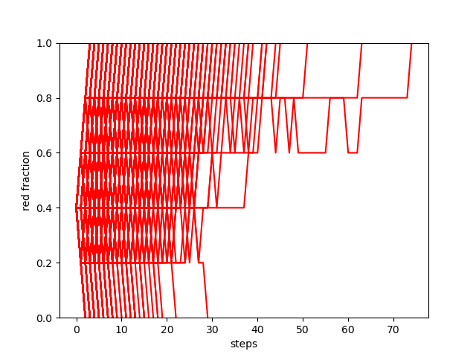תמונה שמכילה טקסט, תרשים, צילום מסך, מלבן

תוכן שנוצר על-ידי בינה מלאכותית עשוי להיות שגוי.

These plots were achieved from N=20, initial number of reds = 1, s=0.2, depth=1000.

**Additional scenarios:**

We implemented in our code an option for two additional scenarios that can be tested individually or simultaneously: one option is to change s in a chosen step throughout the process to a different value, and the other option is to create mutations at a chosen rate. For example, a process with no reds at the initial state (population size 20, all blue individuals) but with a mutation rate of 0.1, with an advantage for reds (s=0.2) would yield generate red individuals throughout the process and will not be able to remain in an absorbing state:

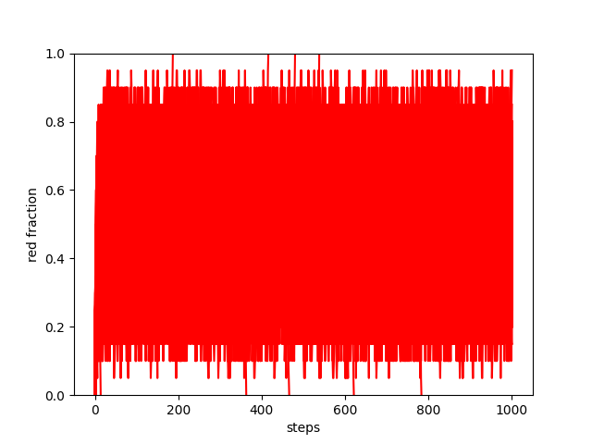תמונה שמכילה טקסט, צילום מסך, תצוגה, מלבן

תוכן שנוצר על-ידי בינה מלאכותית עשוי להיות שגוי.

And a run with no mutations but with a changed s (representing a change in environmental pressures, causing s to change from 0.2 to -0.3 at a random step of the process) would look like this: (the blue line marks the step in which the change of s was introduced).

תמונה שמכילה טקסט, צילום מסך, תרשים, עלילה

תוכן שנוצר על-ידי בינה מלאכותית עשוי להיות שגוי.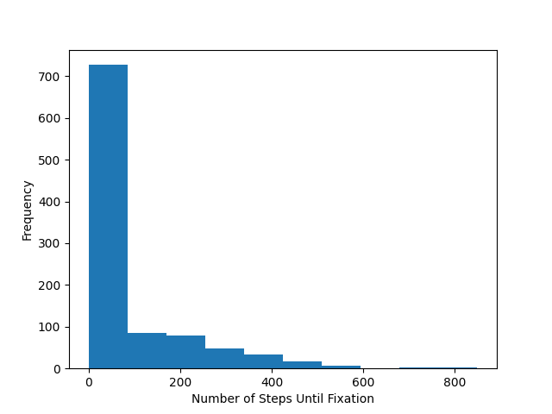

**Explanation:**

The Moren Process introduces a scenario in which mutations never occur, and the probability for a single individual to take over the population is fixed. We introduced two different scenarios that change this paradigm, therefore altering the original model characteristics:

* 1. Mutations: in the original Moran Process there are no mutations, therefore fixation of a single variant is a state of the process that cannot keep changing with time. The ability for mutations enables individuals from the different class to emerge even after reaching fixation (reds can emerge even when the entire population is blue and vice versa), therefore abolishing the possibility of reaching a truly absorbing state and minimizing the true fixation probability.
  2. Change in selection coefficients: the implication of a positive selection coefficient is that an individual has a higher probability to replicate than the other class of individuals, therefore would have a higher probability to fixate. Changing that trajectory mid-process by altering the selection coefficient would either make the process much faster (if s absolute value is increased), or much slower (if s absolute value is decreased). The fixation probability for any non-fixated processes would change according to the new s value, but fixated populations would stay with the initial fixated value.